FITTRACK
PHASE-WISE PROJECT DOCUMENT
Personalized Fitness Recommendations Powered by AI

TEAM MEMBERS
C.ANISHA BEGAM
S.SANTHIYA
M.MONISHA
G.SANTHIYA

PHASE 1 – PROJECT SETUP

1.1 Project Creation
The FitTrack project was created as a backend application for fitness-related functionality. The project was opened in Visual Studio Code and the required backend files were organized in the project folder.

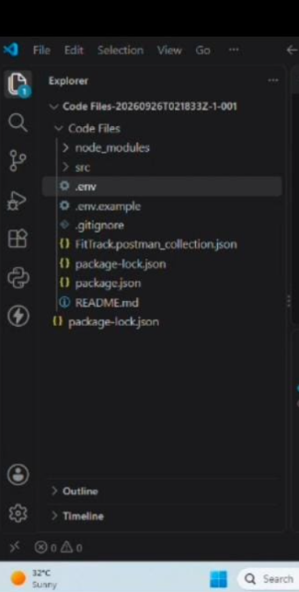

1.2 Project Configuration
The backend project was configured using Node.js and Express.js. The required project files and packages were prepared before implementing the API functionality.

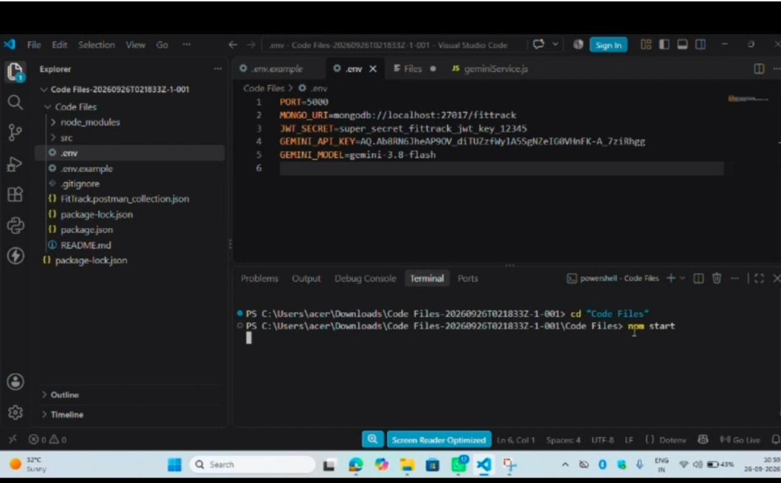

1.3 Server Setup
The backend server was configured to run locally. After starting the server, the API endpoints could be tested using Postman.

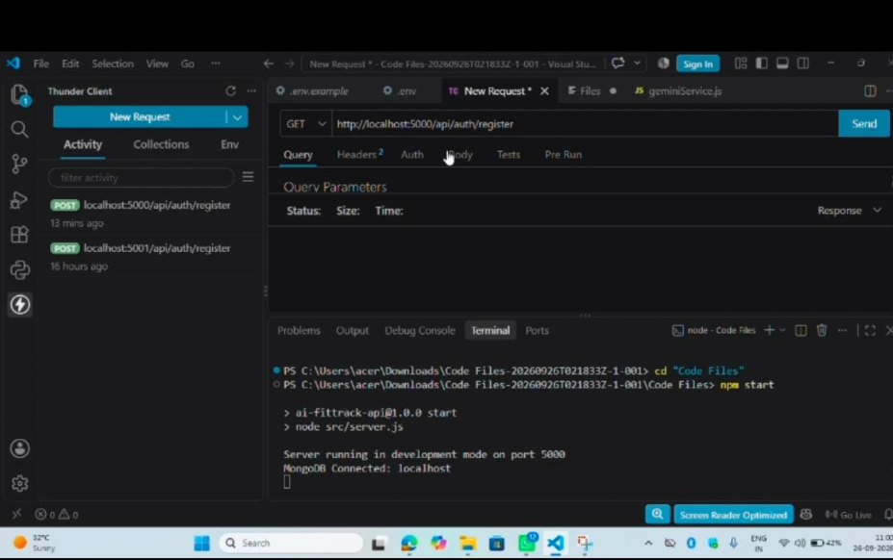

PHASE 2 – BACKEND DEVELOPMENT

2.1 Backend File Development
The backend functionality was implemented by creating and modifying the required JavaScript files. The code was organized according to the functions performed by the application.
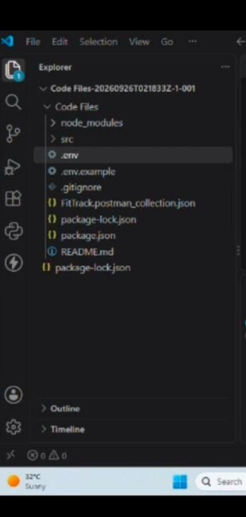

2.2 API Route Implementation
REST API routes were created to receive requests from the API testing tool. The routes process the input and return the required response in JSON format.
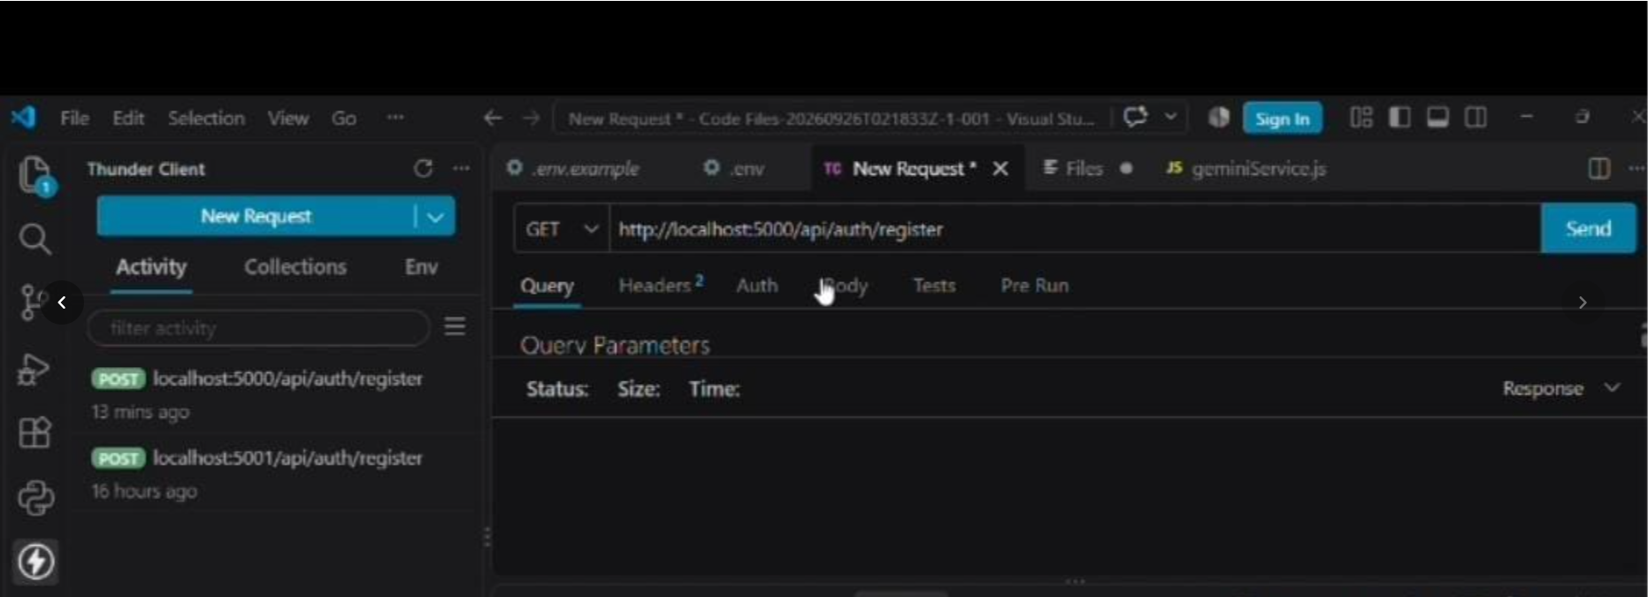

2.3 Request and Response Handling
The backend receives request data, validates the required information, processes the request, and sends a JSON response. Successful and unsuccessful requests are handled separately.
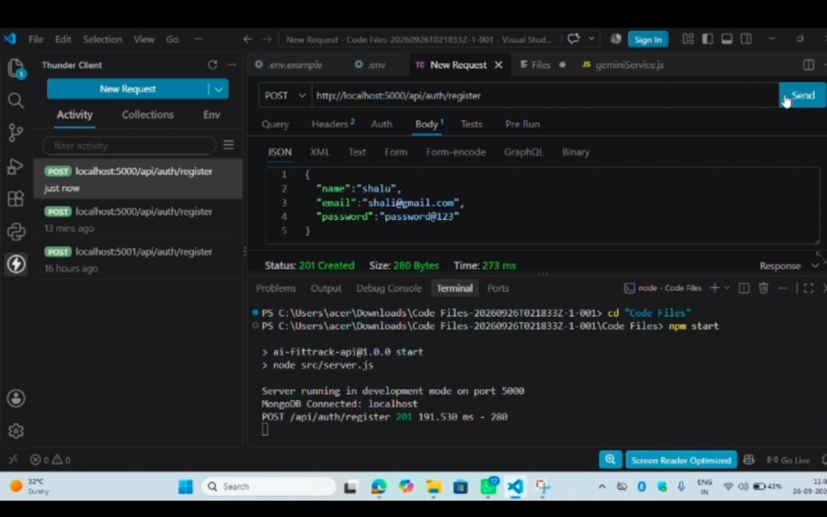

PHASE 3 – AI RECOMMENDATION IMPLEMENTATION

3.1 AI Feature
The FitTrack project includes an AI-powered workout recommendation feature. The feature generates fitness recommendations based on information provided by the user.
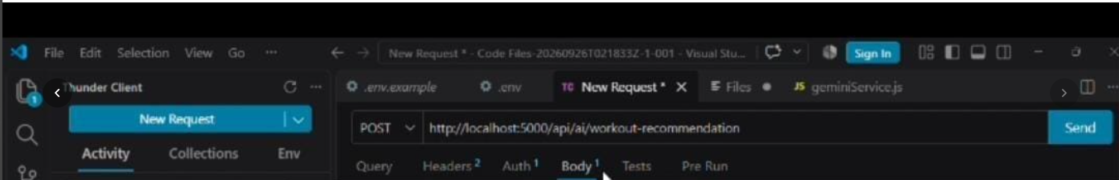

3.2 Input Data
The AI recommendation API accepts the required fitness information from the user. The information is sent to the backend as a JSON request.
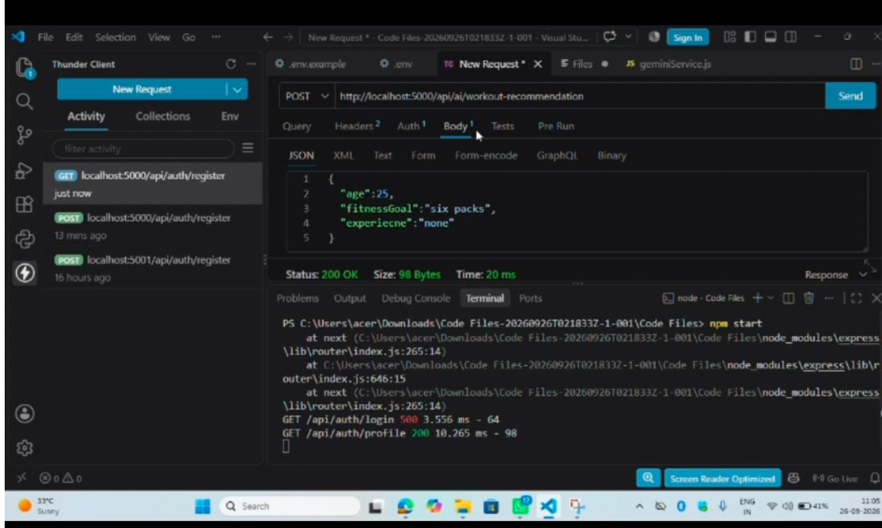

3.3 AI Response
After processing the request, the AI functionality returns a personalized recommendation. The response is displayed as JSON through the API.

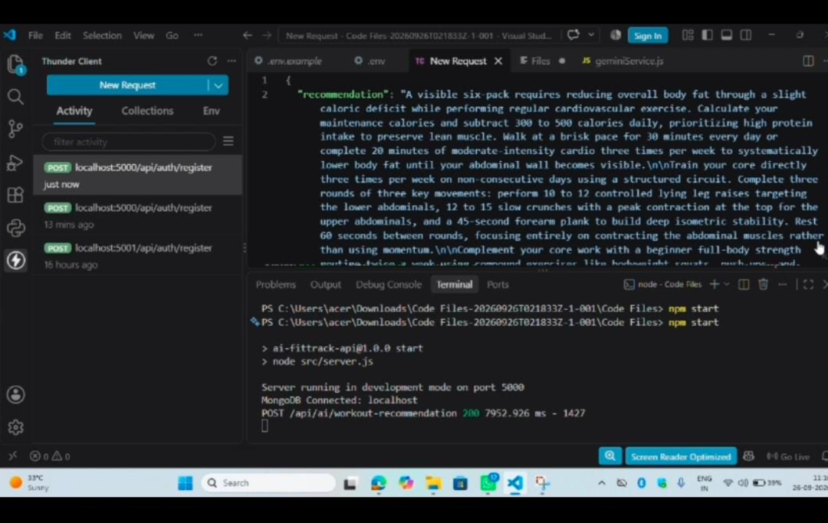

PHASE 4 – API TESTING

4.1 Postman Testing
Postman was used to test the implemented API endpoints. Each API was tested by sending the required request and checking the response returned by the backend.

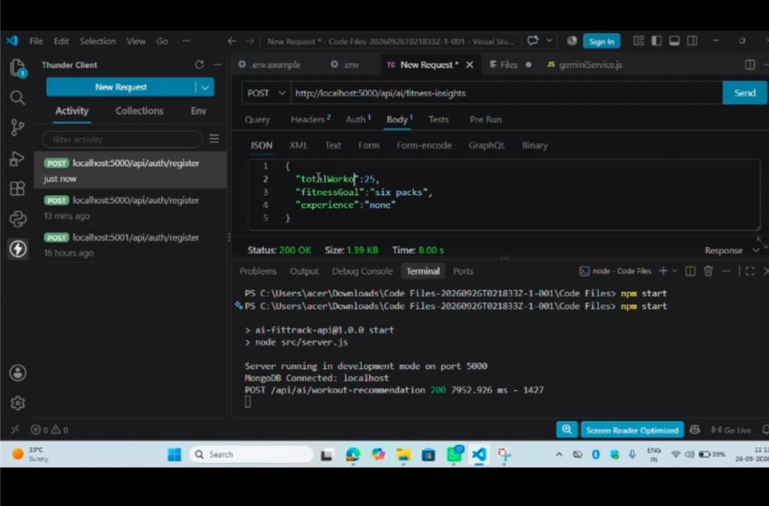

4.2 Successful API Response
The API testing verified that the backend accepts valid input and returns the expected response.

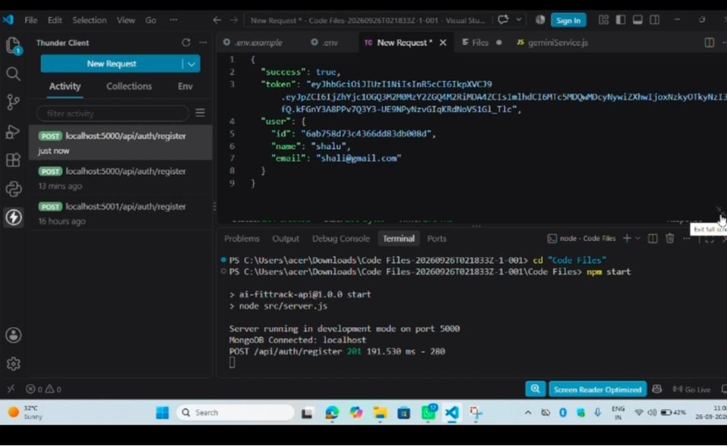

4.3 Error Testing
Invalid or incomplete input was tested to verify that the backend returns an appropriate error response.

PHASE 5 – PROJECT EXECUTION AND RESULT

5.1 Complete Project Execution
The completed FitTrack backend was executed locally and the implemented API functionality was tested. The API requests and responses were verified using Postman.

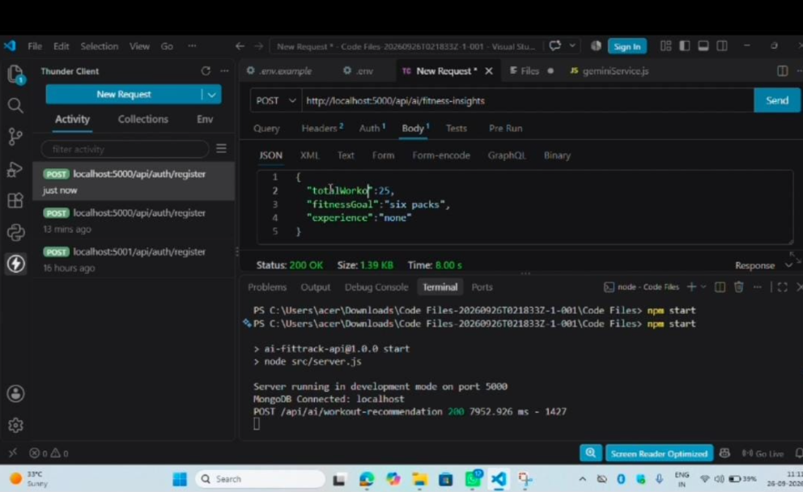

5.2 Final Output
The final output demonstrates that the implemented backend can receive fitness-related information, process the request, and return the required response through the API.

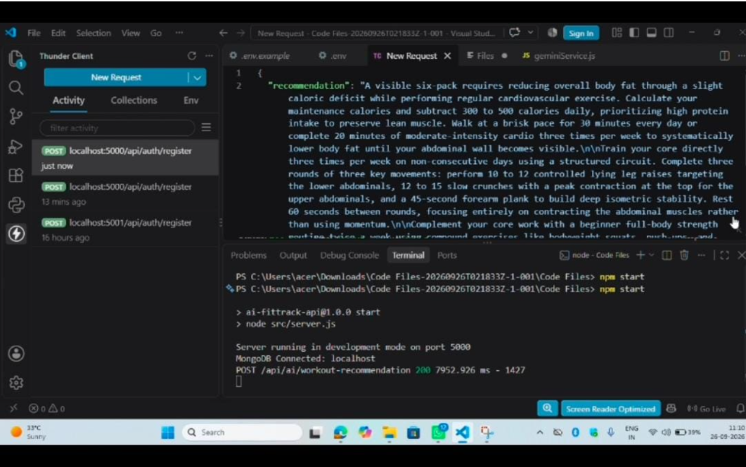

5.3 Result
The FitTrack project was completed with backend API functionality and an AI-powered fitness recommendation feature. The implemented APIs were tested using Postman and the responses were verified.

